**LEARNING OUTCOME**

After completion of this experiment, student will be able to:

1. Understand the basic concept and structure of computer hardware
2. Identify the existing configuration of the computers and peripherals.

**MOTHERBOARD**

Let us begin with the main role of a motherboard. In essence, it serves two purposes:

* Provide electrical power to the individual components
* Provide a route to allow the components to communicate with each other

There are other things a motherboard does (e.g. holds the components in place, or provides feedback as to how well everything is functioning) but the aforementioned aspects are critical to how a PC operates, that almost every other part that makes up the motherboard, is related to these two things.

Nearly every motherboard used in a standard desktop PC today will have sockets for the central processing unit (CPU), memory modules (nearly always a type of DRAM), add-in expansion cards (such a graphics card), storage, input/outputs, and a means to communicate with other computers and systems.

Standard motherboards initially differ in terms of their size, and there are industry-wide standards that manufacturers tend to adhere to (and plenty of others that don't).

The main sizes you're likely to come across are:

* Standard ATX - 12 × 9.6 inches (305 × 244 mm)
* Micro ATX - 9.6 × 9.6 inches (244 × 244 mm)
* Mini ATX - 5.9 × 5.9 inches (150 × 150 mm

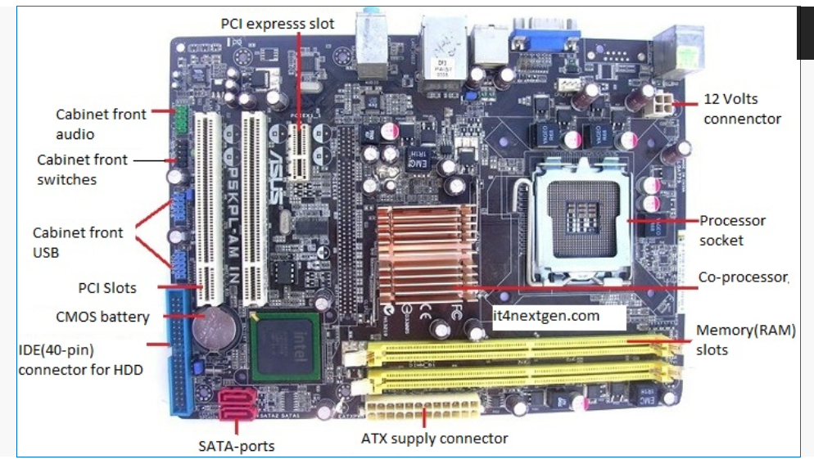

.. . Figure 1. Motherboard and its components

On a motherboard, you can expect to see standard components like capacitors, resistors, and VRMs, which manage the electrical current.

A motherboard is mainly composed of two materials:

* Layers of fiberglass for insulation
* Copper to form conductive pathways

If you’re wondering why motherboards are made in layers, the answer is quite simple: to save space.

Stacking 4-8 layers of copper-embedded fiberglass PCB makes motherboards significantly smaller. This also increases the speed of processing data since electrons have less distance to travel.

Now, unless you know exactly what you are doing, you should never drill into your motherboard! A motherboard is composed of layers that have copper embedded in between fiberglass. If you were to drill through one of the copper lanes, it would be the end of your motherboard. It may seem strange that this is even being mentioned, but there have been instances where people have drilled to accommodate a new aftermarket cooler.

Of course, this doesn't mean the PCB is never drilled; the PCB is pre-drilled before it even arrives at the factory. The drilling is for mounting holes and through holes for attaching and soldering components. Vertical interconnect access (VIAS) will also be soldered onto the motherboard and is basically electrical connections between the copper layers.

.. . Video 1. Inside a computer and a laptop

**Some of popular manufacturers of the motherboard.**

* Intel
* ASUS
* AOpen
* ABIT
* Biostar
* Gigabyte
* MSI

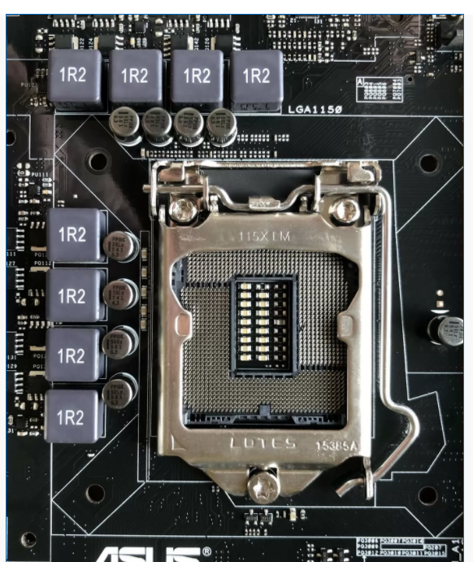

.. . Fig 2. A CPU socket which hold CPU

The metal bracket holds the CPU in place but it's getting in the way of seeing the pins clearly, so let's move it to one side.

.. . 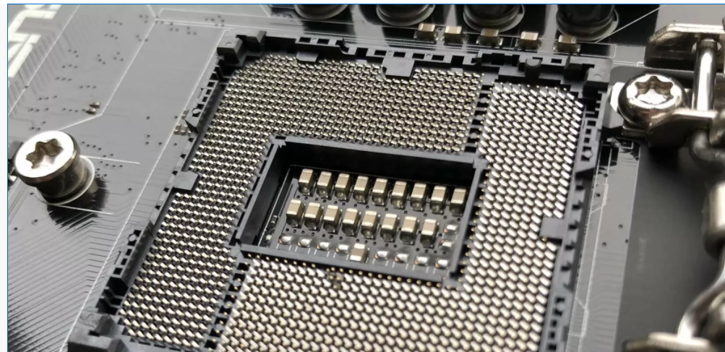. Fig 3. Central Processing Unit

In general, the more capable the CPU (in terms of number of cores, amount of cache, etc), the more pins will be found in the socket. A large number of these connections will be used to send and receive data to the next important feature on a motherboard.

**Big brains need big memory**

The sockets or slots that are always the closest to the CPU are those that hold [*DRAM*](https://en.wikipedia.org/wiki/Dynamic_random-access_memory)*modules*, aka *system memory*. These are connected directly to the CPU and nothing else on the motherboard. The number of DRAM slots depend mostly on the CPU, as the controller for the memory is built into the central processor.

In the example we're looking at, the CPU that fits into this motherboard has 2 memory controllers, with each one handling 2 sticks of memory - hence there are 4 sockets in total. You can see that, on this motherboard, the memory sockets are colored in way to let you know which ones are managed by which controller. They're commonly called *memory channels*, so channel #1 handles two of the slots and channel #2 handles the other two.

.. . . 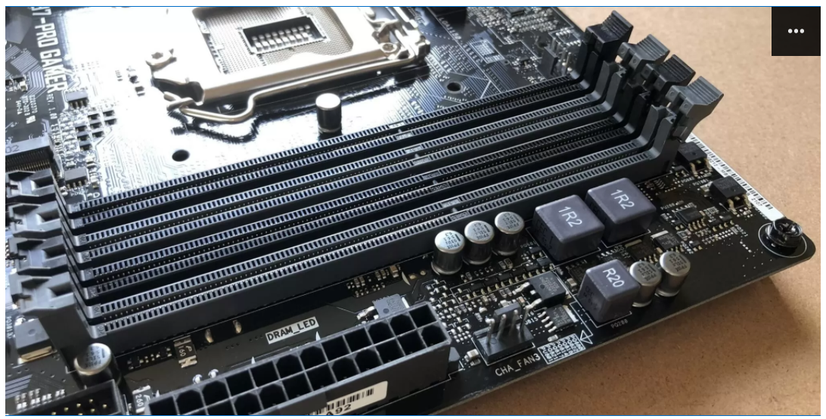Fig 4. Memory Slots

For this particular motherboard, the colors of the slots can be a little confusing: the two black slots are actually one each for the two memory controllers (and same for the grey ones). So the black slot closest to the CPU socket is channel #1, and the next black one is channel #2.

It's colored like this to encourage you use the motherboard in what is called *dual memory channel mode* - by using both controllers at the same time, the overall performance of the memory system is increased. So let's say you had two RAM modules, each one 8 GB in size. No matter what slots you put them in, you'll always have a total of 16 GB of available memory.

However, if you put both modules into both of the black slots (or both of the grey slots), the CPU will essentially have double the routes possible to access that memory. Do it the other way (one module in each color) and the system will be forced to access the memory with just the one memory controller. Given that it can only manage one route at a time, it's not hard to see how this doesn't help performance.

This CPU/motherboard combination uses DDR3 SDRAM (double data rate version 3, synchronous dynamic random access memory) chips and each socket holds one SIMM or DIMM. The 'IMM' part stands for *Inline Memory Module*; the S and D refers to where the module has one side filled with chips or both sides (*single* or *dual*).

Along the bottom edge of the memory module are lots of gold plated connectors, and this type of memory has 240 of them in total (120 each side). These provide the power and data signals for the chips.

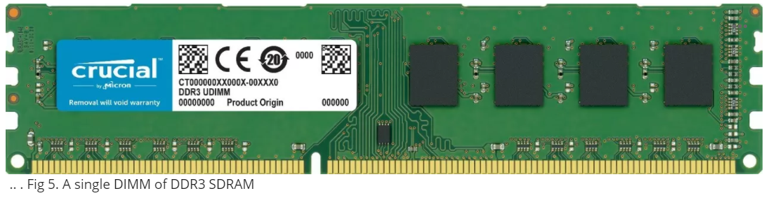

.. . Fig 5. A single DIMM of DDR3 SDRAM

Bigger modules would allow you to have more memory, but the whole setup is limited by the pins on the CPU (almost half of the 1150 pins in this example are dedicated to handle these memory chips) and space for all of the traces or electrical wires in the motherboard.

The computer industry has stuck with using 240 pins on memory modules since 2004 and shows no signs of changing any time soon. To improve memory performance, the chips simply run faster with each new version released. In the example we're looking at, the CPU's memory controllers can each send and receive 64 bits of data per clock cycle. So with two controllers, the memory sticks will having 128 pins dedicated to transferring information. So why 240 pins?

Each memory chip on the DIMM (16 in total, 8 per side) can transfer 8 bits per clock cycle. That means each chip needs 8 pins, just for data transfers; however, two chips share the same data pins, so only 64 of the 240 are data ones. The remaining 176 pins are required for timing and reference purposes, transmitting the addresses of the data (location of where the data is on the module), controlling the chips, and providing electrical power.

So you can see that having more than 240 pins won't necessarily make things better!

*RAM comes in two sizes: DIMM (Dual In-Line Memory Module), which is found in desktops and servers, and SO-DIMM (Small Outline DIMM), which is found in laptops and other small form factor computers.*

**RAM isn't the only thing that's hooked up to the CPU**

System memory is connected directly to the central processor to boost performance, but there are other sockets on the motherboard that are wired a bit like this (and for the same reason). They use a connection technology called [*PCI Express*](https://en.wikipedia.org/wiki/PCI_Express) (PCIe, for short) and every modern CPU has a PCIe controller built into it.

These controllers can handle multiple connections (typically referred to as *lanes*), even though it is a 'point-to-point' system, meaning that the lanes in the socket aren't shared with any other device. In our example, the CPU's PCI Express controller has 16 lanes.

The image below shows 3 sockets: the top two are PCI Express, while the bottom one is a much older system called [PCI](https://en.wikipedia.org/wiki/Conventional_PCI) (related to PCIe, but a *lot*slower). The little one at the top is labelled PCIEX1_1 because it is a single lane socket; the one below it is a 16 lane socket.

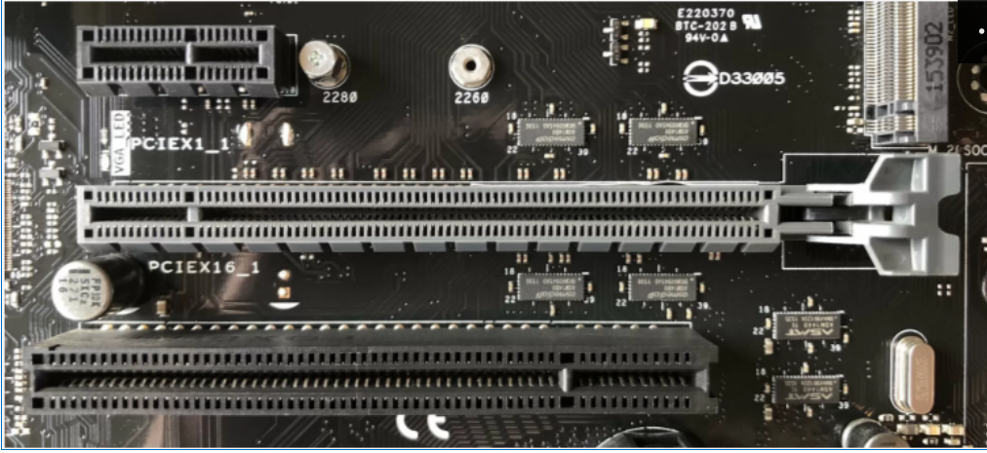

.. . Fig 6. PCI Slots

If you scroll back up and look at the whole motherboard again, you can see that there are:

* 2x PCI Express 1 lane sockets
* 3x PCI Express 16 lane sockets
* 2x PCI sockets

But if the CPU's controller only has 16 lanes, what's going on? First of all, only PCIEX16_1 and PCIEX16_2 are connected to the CPU - the third one, and the two single lane sockets are connected to another processor on the motherboard (more about that in a moment). Secondly, if both sockets were filled with devices that use 16 PCIe lanes, then the CPU will only dedicate 8 lanes to each.

This is the case of all CPUs today; they have a limited number of lanes, so as more devices get connected to the CPU, each one gets a smaller number of lanes to work with.

Different CPU and motherboard configurations have their own way of handling of this. For example, [Gigabyte's B450M Gaming](https://www.gigabyte.com/Motherboard/B450M-GAMING-rev-10#kf) motherboard has one PCIe 16 lane socket, one PCIe 4 lane socket and a M.2 socket that uses 4 PCIe lanes. With only 16 lanes available from the CPU, using any two sockets will force the larger x16 one to be capped to 8 lanes.

So what kind of things use those sockets? The most common choices are:

* 16 lanes = graphics card
* 4 lanes = solid state drives (SSD storage)
* 1 lane = sound cards, network adapters

**Let's head south and cross the bridge**

If we go back 15 years or so, and look at motherboards from that era, there were two additional chips built into them to support the CPU. Together, they were called a *chip set* (usually concatenated to chipset), and individually they were called the *Northbridge*(NB) and *Southbridge*(SB) chips.

The former handled the system memory and graphics card, the latter processed the data and instructions for everything else.

.. 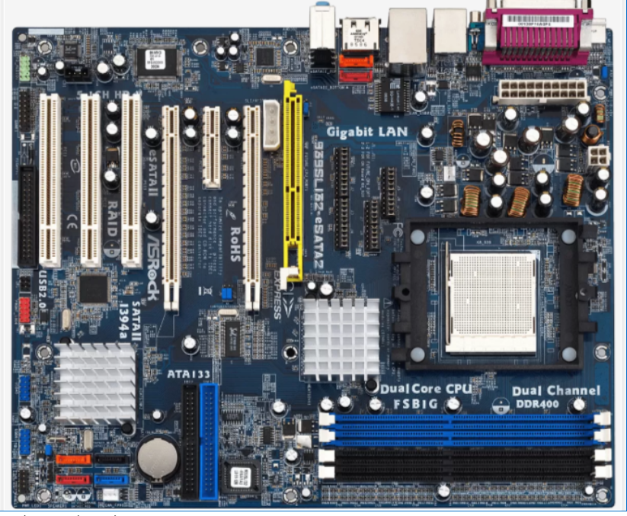 . Fig 7. North Bridge South Bridge

The above image, of an [ASRock 939SLI32](https://www.asrock.com/mb/ULi/939SLI32-eSATA2/) motherboard, clearly shows the NB/SB chips - they're both hidden under aluminum heatsinks, but the one closest to the CPU socket in the middle of the image is the Northbridge. A few years after this product was around, both Intel and AMD released CPUs that had the NB integrated into the central processor.

The Southbridge, though, has remained separate and is likely to be so for the foreseeable future. Interestingly, both CPU manufacturers have stopped calling it the SB and often refer to it as the chipset (Intel's proper name for it is the PCH, *platform controller hub*), even though it's just a single chip!

*On our more modern example from Asus, the SB is also covered with a heatsink, so let's pop it off and have a look at the extra processor.*

**Platform Controller Hub**

The Platform Controller Hub (PCH) is a family of Intel's single-chip chipsets, first introduced in 2009. It is the successor to the Intel Hub Architecture, which used two chips - a northbridge and southbridge instead, and first appeared in the Intel 5 Series.

The PCH controls certain data paths and support functions used in conjunction with Intel CPUs. These include clocking (the system clock), Flexible Display Interface (FDI) and Direct Media Interface (DMI), although FDI is used only when the chipset is required to support a processor with integrated graphics. As such, I/O functions are reassigned between this new central hub and the CPU compared to the previous architecture: some northbridge functions, the memory controller and PCI-e lanes, were integrated into the CPU while the PCH took over the remaining functions in addition to the traditional roles of the southbridge. AMD has its equivalent for the PCH, known simply as a chipset, no longer using the previous term Fusion controller hub since the release of the Zen architecture in 2017.

.. . 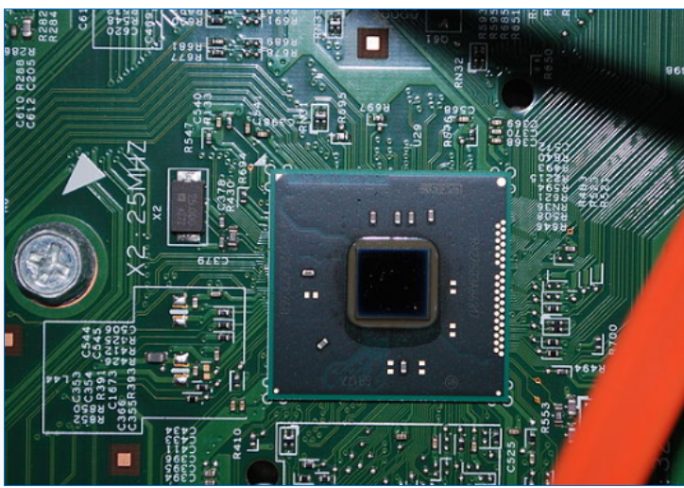 Fig 8. PCH

**Different types of motherboards:**

**1.AT Motherboards (No longer used)**

The oldest of the main boards, these motherboards were used in earlier 286/386 or 486 computers. The AT means the board consists of advanced technology(AT) power connectors. There are two power connectors of 6 pin each mounted on the AT motherboards. The AT motherboards were available in the early 80’s.

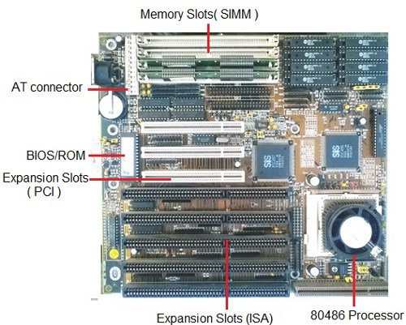

.. . Fig 9. AT Motherboard

**2.ATX Motherboards**

The ATX motherboards started in 90’s and are still available. The ATX connector on the motherboard consists of a single connector. These boards are used for P2/P3 or P/4 processors.

. 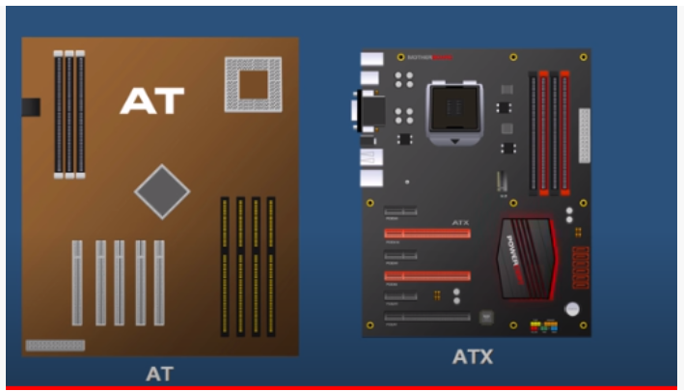 . Fig AT v/s ATX

**Motherboard for P1/P2 processors**:

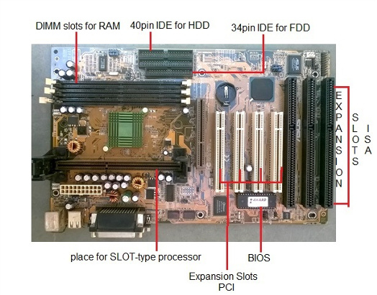

.. . Fig 10. ATX Motherboard

**Motherboard Components**

The motherboard consists of various components which have their own role to play in the functioning of a computer. Let us discuss various motherboard components and know their definition and role.

**Expansion Slots**

**ISA slots.** These were the oldest expansion slots in the history of motherboards. They were found in AT boards and are identified by black color. Conventional [display cards](http://www.it4nextgen.com/pc-expansion-cards/) or sound cards were installed in these slots. The full form of ISA is **Industry Standard Architecture** and is a 16- bit bus.

**PCI Slots.** The full form of PCI is Peripheral Component Interconnect. The PCI slot is one of the important motherboard components today and is vastly used to install [add-on cards](http://www.it4nextgen.com/pc-expansion-cards/)on the motherboard**.**The PCI supports 64-bit high-speed bus.

**PCI express**. Also known as PCIe, these are the latest and the fastest component of the motherboard to support add-on cards. It supports full duplex serial bus.

**AGP slot.** Accelerated graphics port(AGP) is specifically used to install a latest graphics card. AGP runs on a 32-bit bus and both PCIe and AGP can be used to install high-end gaming display cards.

**RAM(memory) slots**

* **SIMM slots**. The full form is a single in-line [memory](http://www.it4nextgen.com/computer-memory-types/) module. These slots were found in older motherboards, up to 486-boards. The SIMM supports 32-bit bus.
* **DIMM slots**. The full form of DIMM is a Double inline memory module. These are the latest [RAM](http://www.it4nextgen.com/computer-memory-types/) slots which run on a faster 64-bit bus. The DIMM used on Laptop boards are called SO-DIMM.

**CPU Socket**

Another vital motherboard component is the [CPU](http://www.it4nextgen.com/what-is-a-cpu-central-processing-unit/) socket which is used to install the processor on the motherboard. A CPU slot, also called a CPU socket or Processor socket, contains one or more mechanical components that provide mechanical and electrical connections between the PCB and a microprocessor (CPU). Therefore, you can install a CPU on a motherboard without soldering. Some important sockets are explained below.

**Socket7.** It is a 321 pin socket that supported older processors like Intel Pentium 1/2/MMX, AMD k5/K6, and Cyrix M2.

**Socket370.** It is a 370 pin socket that supports Celeron processors and Pentium-3 processors.

**Socket 775.** It is a 775-pin socket that supports Inter dual core, C2D, P-4 and Xeon processors.

**Socket 1156.** Found on latest types of motherboards, it is an 1156-pin socket that supports latest Intel i-3, i-5 and i-7 processors.

**Socket 1366.** The socket is of 1366 pins and supports latest i-7 900 processors.

**BIOS**

The full form of BIOS is Basic Input Output System. It is a motherboard component in the form of a Integrated chip. This chip contains all the information and settings of the motherboard which you can modify by entering the BIOS mode from your computer. The BIOS firmware is the first software to run when powered on; it is re-installed on a PC’s system board.

Apart from operating system and applications, BIOS is the third type of software your computer needs to operate successfully.

.. . 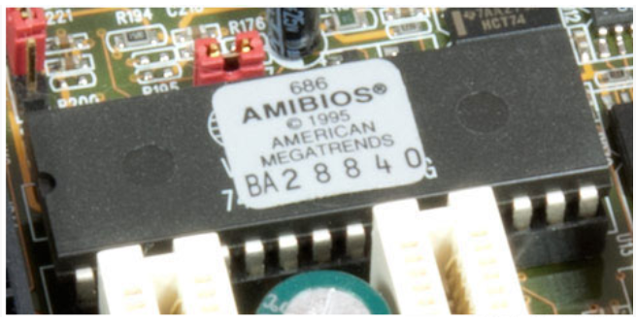 Fig 11 BIOS Chip

Every computer has BIOS pre-programmed into its hardware. It’s different than an operating system. Operating systems can be installed, uninstalled, and updated long after you’ve bought the computer. BIOS is something that’s integrated into the computer while it’s being manufactured.

BIOS stands for “Basic Input/Output System.” What exactly does it do? Basically, it manages the essential functions of your computer.

The BIOS software has a number of different roles, but its most important role is to load the operating system. When you turn on your computer and the microprocessor tries to execute its first instruction, it has to get that instruction from somewhere. It cannot get it from the operating system because the operating system is located on a hard disk, and the microprocessor cannot get to it without some instructions that tell it how. The BIOS provides those instructions. Some of the other common tasks that the BIOS performs include:

* A power-on self-test (POST) for all of the different hardware components in the system to make sure everything is working properly
* Activating other BIOS chips on different cards installed in the computer - For example, SCSI and graphics cards often have their own BIOS chips.
* Providing a set of low-level routines that the operating system uses to interface to different hardware devices - It is these routines that give the BIOS its name. They manage things like the keyboard, the screen, and the serial and parallel ports, especially when the computer is booting.
* Managing a collection of settings for the hard disks, clock, etc.

When you turn on your computer, the BIOS does several things. This is its usual sequence:

1. Check the CMOS Setup for custom settings
2. Load the interrupt handlers and device drivers
3. Initialize registers and power management
4. Perform the power-on self-test (POST)
5. Display system settings
6. Determine which devices are bootable
7. Initiate the bootstrap sequence

The BIOS is special software that interfaces the major hardware components of your computer with the operating system. It is usually stored on a Flash memory chip on the motherboard, but sometimes the chip is another type of ROM.

Everything your computer does can be boiled down to an input or output. The BIOS is tasked with managing your computer’s exchange of inputs and outputs, mostly when you’re booting up your computer. BIOS instructs your computer on how to boot up the operating system, and it also operates the peripherals (like the mouse and keyboard).

You press the power key to turn on your laptop, right? Well, how’s your laptop supposed to process the power key when the laptop is turned off? That’s what the BIOS is there for. It performs basic functions for your computer while your computer is still waking up. Pressing the power key is a basic input. Booting up your operating system is the basic output.

If you’re a PC gamer, you might be interested in learning how to [overclock your computer](https://store.hp.com/us/en/tech-takes/how-to-overclock-pc-cpu) to boost your processing speed while you’re gaming. You can program your computer for overclocking by adjusting the BIOS settings. We’ll teach you how to use BIOS to overclock at the end of this article.

**CMOS (Complementary Metal-oxide-semiconductor) Battery**

The battery or a cell is a 3.0 Volts lithium type cell. The cell is responsible for storing the information in BIOS and the full form is Complementary Metal Oxide Semi-Conductor.  CMOS Battery also store date and time. The CMOS battery powers the BIOS firmware in your laptop.

BIOS needs to remain operational even when your computer isn’t plugged into a power source. That’s where the battery comes in. When your computer gets unplugged, BIOS relies on the CMOS battery for power.

You’ll find CMOS batteries in both laptops and desktop PCs, but it’s used more frequently in a laptop. That’s because laptops are usually unplugged for a longer amount of time than desktop PCs. Most desktop PCs are unplugged from their power source very infrequently.

The CMOS battery gets charged whenever your laptop is plugged in. It’s only when your laptop is unplugged that the battery loses charge. Most batteries will last 2 to 10 years from the date they’re manufactured. The more you leave your laptop plugged in, the longer your battery will last.

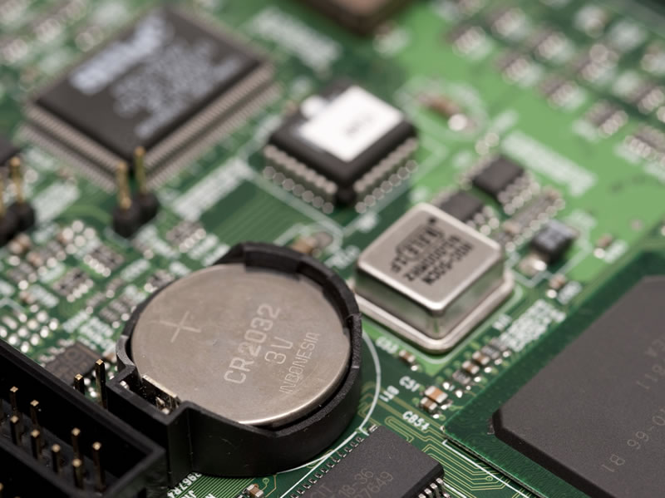

.. . Fig 11. CMOS battery

**Power Connectors**

In order to receive power from [SMPS](http://www.it4nextgen.com/computer-smps/)**,**there are connectors mounted on the motherboards.

AT connector. It consists of 2 number of 6 pin male connectors and is found on old types of motherboards.

ATX connector. The latest in the series of power connectors, they are either 20 or 24 pin female connectors. Found in all the latest types of motherboards.

**IDE connector**

The Integrated Drive Electronics (IDE) connectors are used to interface disk drives. The 40-pin male connector is used to connect IDE [hard disk drives](http://www.it4nextgen.com/computer-hard-drive/) and the 34-pin male connector connects to Floppy Disk Drive.

**SATA connector**

Latest in the series, the connectors, Serial Advance Technology Attachment(SATA) are 7-pin connectors to interface latest SATA hard disks or [optical drives](http://www.it4nextgen.com/optical-disk-drives-parts-working/). They are much faster than IDE interface.

**Co-Processor**

The co-processor is one of the important motherboard components and helps the main processor in mathematical calculations and computer graphics.

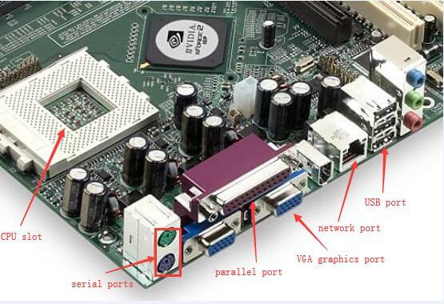

.. . Fig 12. Ports

**Parallel port**

A parallel port is a kind of interface for attaching peripherals on desktops. The name of this kind of port is derived from the way the data is sent. That is, the parallel ports send multiple bits of data at the same time. Serial interfaces, on the contrary, send bits one data at once. To achieve parallel data transfer, there are multiple data lines in the parallel port cables. The parallel port cable is larger than the cable of a contemporary serial port, which only has one data line within.

**Mouse & keyboard :**

There are two types of keyboard and mouse connectors.First type is called PS/2 and second one is called USB.

. 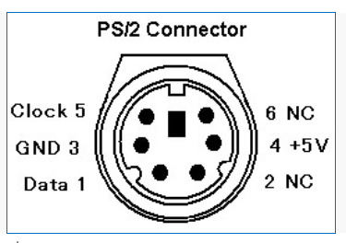. . Fig 13 Mouse and Keyboard Connector type

**Cabinet connections**

The cabinet in which the motherboard is installed has many buttons that connect to the motherboard. Some of the common connectors are Power Switch, Reset Switch, Front [USB](http://www.it4nextgen.com/usb-connectors-definition-types-compatibility/), Front Audio, Power indicator(LED) and HDD LED.